Scrum - Artifacts Workbook
Definition of Done
Definition | The definition of ‘done’ is a well-understood and clearly documented definition of items that must be established to mark a story (or iteration or project) to be complete.
Purpose | Getting a story to a completed state per the definition of done should be the goal of a team and should be used as the basis for planning.

Product Backlog
Definition | The Product Backlog is used to document the wants and needs for “stuff,” which is prioritized by how much value it is to the business.
Purpose | Meant to act as a work checklist in a sense.
Ordering | Items are arranged based on value to the business, it’s an ordered list of all user requests/requirements.
Product Backlog Grooming | Product Backlog is constantly re-evaluated and re-ordered, and items added or removed in a process are called Product Backlog Grooming.
Large Items | Epics - broken down into smaller digestible chunks before considered for work being done.
PBIs | Each entry in a backlog is called a Product Backlog Item(PBI)

Sprint Backlog
Definition | Ordered list of requirements for a project, assignment, etc.
Purpose | Meant to act as a more immediate PBI where tasks are chosen based on the importance of the task and typically are higher priority.
Source of items | Items are pulled from the Product Backlog.
How are items chosen? | They are chosen by the development team and based on the amount of work required to complete. Often choose from the highest priority value.
What does value  orientation vs. results orientation mean? | Value orientation is meant to focus on maximizing business value whereas results orientation is off of the predetermined results regardless of what the actual result is.
Task Board | Tracks the steps of the process for each item on the Spring backlog - includes steps like “Tasks, in progress, stopped, and completed.”  Tasks are tracked progressively to completion.  Task Board is re-evaluated every day during the daily standup.
Sprint Backlog Item | Sprint Backlog items are broken down into tasks with each task having a planned maximum duration of two days.

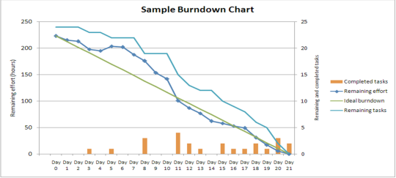Burndown Chart
Purpose | Shows remaining work in Sprint Backlog, will see how much more effort will be needed over time as more tasks are completed.
How is it updated? | It’s updated based on the Sprint progression.
How often is  it used? | It’s assessed and used daily
Significance? | Keeps track of the current sprint progression and the remaining tasks/effort needed to complete it.
User Stories
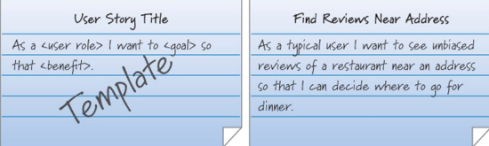
Definition | Describes what the user needs to do in the job function.
Purpose | Used as the basis for defining the function of the business system.  Used as a basis for requirements gathering.  “Who, what, why”
Format | They are often written on small note cards and one or more sentences are written in everyday business language.
Source | Becomes the representation of a Product Backlog Item (PBI).
Attributes for completeness | Name, brief narrative, acceptance criteria,  any defined conditions

Estimation

Story Points | Choosing enough work to fill up a full sprint:  Based on relative effort.  Show only the relative size of the item - not the time to complete.  Teams pick a simple, agreed-upon basis.  Used for Estimation Activities.
Planning Poker | Determining the amount of work for each  Product Backlog Item  Based on the Fibonacci Sequence:  Each numbered card represents the amount of work the team member believes this item represents.  Each development team member is issued one set of cards.  If, when hands are shown, there is not a clear agreement on the amount of work involved, high and low bidders will explain why they chose that bid.  The team will re-vote until they reach a consensus.
Fibonacci  Sequence | The Fibonacci sequence is a type of series where each number is the sum of the two that precede it. 1, 1, 2, 3, 5, 8, 13, 21, 34, 55. Meant to be used in the Planning Poker estimation.

